Power over Ethernet (PoE)

⚡ What Is Power over Ethernet (PoE)?
# Source: AI Source: Provided by: [Data Path: Persons Table -> ID Column: 1, Name_En Column: Motasem Essam] -> From: [ChatGPT] on [12/18/2025]
Power over Ethernet (PoE) is a technology that allows electrical power and data to be delivered over a single Ethernet cable (typically Cat5e or higher). This means you can power devices like cameras, access points, or VoIP phones without needing a separate power supply.

Power over Ethernet (PoE) Image
# Source: ScreenShots Source: Provided by: [Persons Table -> ID Column: 1, Name_En Column: Motasem Essam] -> Tool: [Lightshot Program] -> From [Site: Google Search: Images: Power over Ethernet (PoE)] on [12/18/2025]
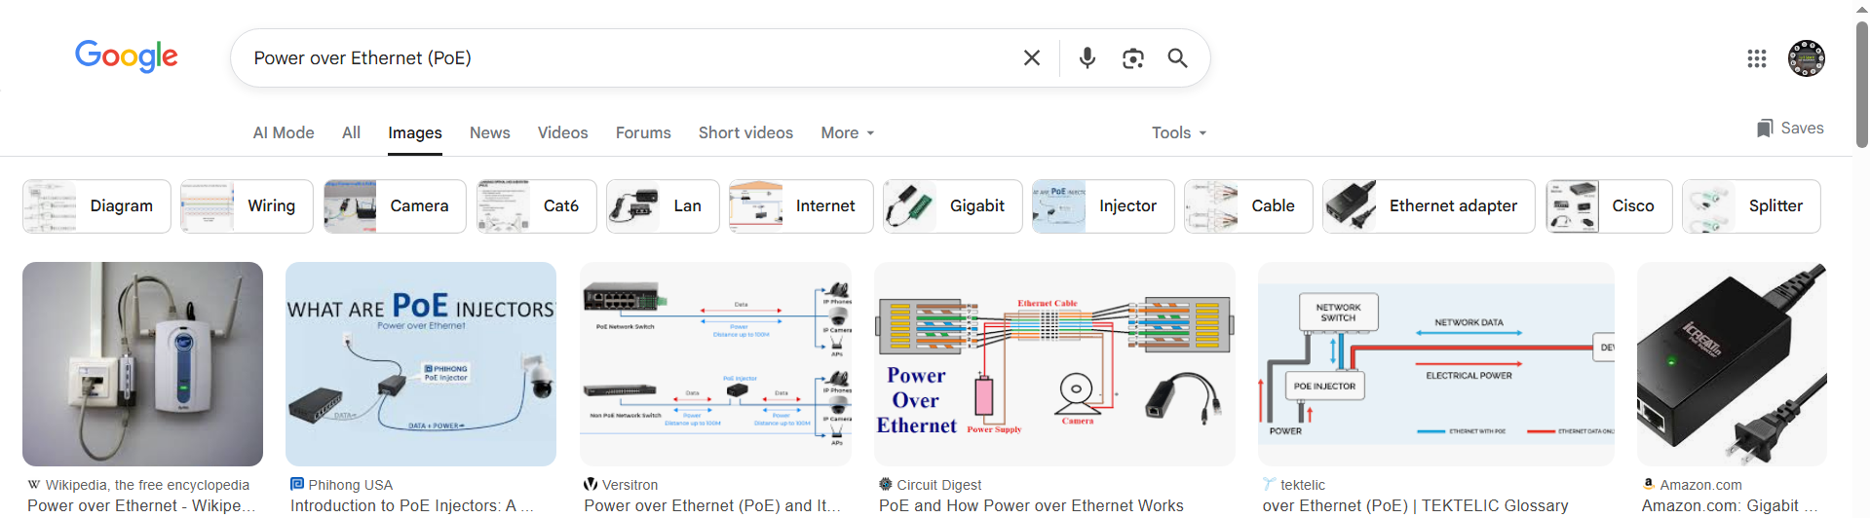

📦 Belongs to:
# Source: AI Source: Provided by: [Data Path: Persons Table -> ID Column: 1, Name_En Column: Motasem Essam] -> From: [ChatGPT] on [12/18/2025]
✅ Types of Network Cables / Network Features

🧠 Key Concept
# Source: AI Source: Provided by: [Data Path: Persons Table -> ID Column: 1, Name_En Column: Motasem Essam] -> From: [ChatGPT] on [12/18/2025]
PoE combines data transmission and DC power delivery on standard twisted-pair Ethernet cables.

🔌 How It Works
# Source: AI Source: Provided by: [Data Path: Persons Table -> ID Column: 1, Name_En Column: Motasem Essam] -> From: [ChatGPT] on [12/18/2025]
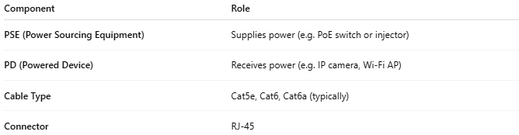
Component | Role
PSE (Power Sourcing Equipment) | Supplies power (e.g. PoE switch or injector)
PD (Powered Device) | Receives power (e.g. IP camera, Wi-Fi AP)
Cable Type | Cat5e, Cat6, Cat6a (typically)
Connector | RJ-45

🔋 PoE Standards
# Source: AI Source: Provided by: [Data Path: Persons Table -> ID Column: 1, Name_En Column: Motasem Essam] -> From: [ChatGPT] on [12/18/2025]
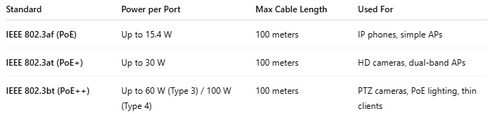
Standard | Power per Port | Max Cable Length | Used For
IEEE 802.3af (PoE) | Up to 15.4 W | 100 meters | IP phones, simple APs
IEEE 802.3at (PoE+) | Up to 30 W | 100 meters | HD cameras, dual-band APs
IEEE 802.3bt (PoE++) | Up to 60 W (Type 3) / 100 W (Type 4) | 100 meters | PTZ cameras, PoE lighting, thin clients

🧾 Common PoE Devices
# Source: AI Source: Provided by: [Data Path: Persons Table -> ID Column: 1, Name_En Column: Motasem Essam] -> From: [ChatGPT] on [12/18/2025]
- 📷 IP Cameras (especially in security systems)
- 📶 Wireless Access Points (WAPs)
- ☎️ VoIP Phones
- 🚪 Door access control systems
- 💡 PoE-powered LED lights

✅ Advantages
# Source: AI Source: Provided by: [Data Path: Persons Table -> ID Column: 1, Name_En Column: Motasem Essam] -> From: [ChatGPT] on [12/18/2025]
- 🔌 Single cable for power + data = less wiring
- 🧰 Easy installation (especially in hard-to-reach places)
- 🔄 Centralized power management via PoE switches
- ⚡ Safe and intelligent — only delivers power when a device is PoE-compatible

❌ Disadvantages
# Source: AI Source: Provided by: [Data Path: Persons Table -> ID Column: 1, Name_En Column: Motasem Essam] -> From: [ChatGPT] on [12/18/2025]
- 📏 Still limited to 100m cable length
- ⚙️ Higher power devices (e.g., computers) need more than PoE offers
- 💰 PoE switches and injectors can be more expensive

📌 Summary
# Source: AI Source: Provided by: [Data Path: Persons Table -> ID Column: 1, Name_En Column: Motasem Essam] -> From: [ChatGPT] on [12/18/2025]
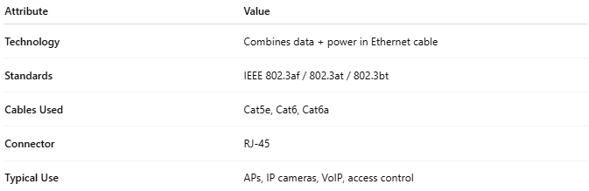
Attribute | Value
Technology | Combines data + power in Ethernet cable
Standards | IEEE 802.3af / 802.3at / 802.3bt
Cables Used | Cat5e, Cat6, Cat6a
Connector | RJ-45
Typical Use | APs, IP cameras, VoIP, access control

